Winter Work report summary

Date submitted:30th Dec 2019 Name: Pranjal Mishra Subsystem: Coding

1.Robocon progress –

1. Bot Navigation

* Made the bot base move in all directions.
* Understood the mechanics of the wheels and the mathematics for finding the net velocity.

2)PS2 controller

* Interfaced the ps2 shield with the with the controller
* Used the joystick to control the base and the action buttons to perform specific tasks

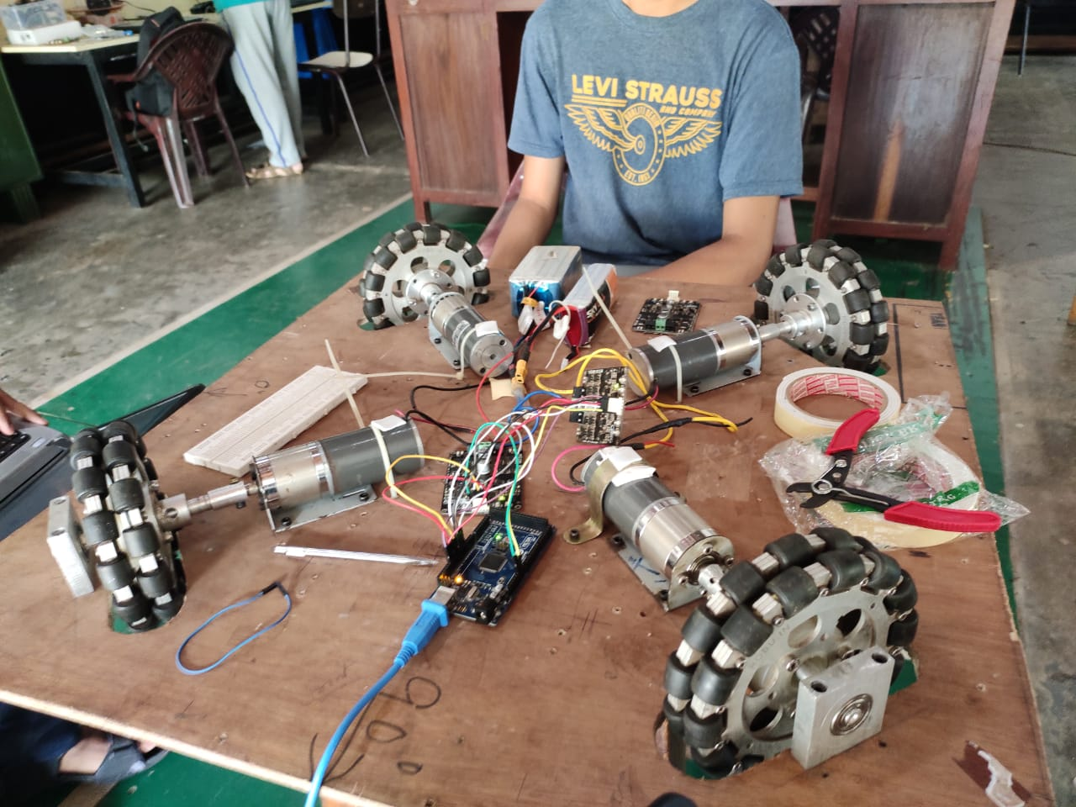

**ISSUES FACED**

1. Was not able to perfect the LSA’s for the line following bot. The sensor seemed to be sending vague values even after calibration.
2. Coursera progress-
3. **Mathematics for machine learning**

Have reached the end for the 1st course and will start the second one

1. **Python courses**

Finished the python basics course and currently doing the python data structures course. Both are offered by the University of Michigan

1. Miscellaneous-
2. **PID**

Learned about PID controler. Understood the mathematics behind it and went through several examples including PID control in drones and autonomous cars.

**2)LIBRARIES**

Worked with various libraries and understood the working of every function